1. **Splitting Apps Into Components**

* -: That's the project you can find attached to this lecture here
* It allows us to define a server name here and then some content for this server And then we can either add a server or a blueprint

* Now this app is all running in one component as of now, in the app component here in the template

* We got a lot of code and we can do better. We can split this up because that's not ideal, having all the logic in this component here maybe splitting it up makes sense because that would also allow us, if we build a big app to reuse parts of that
* So how could we split this up? We could create a new component for this whole cockpit here where we enter a name and content and click the buttons
* And of course we could also create component, a component for an individual server
* And with that we should have a much leaner app component, HTML file, and we will bundle our business logic better into individual components

**Cockpit Component and Server Element Component:**

* Now we can of course take our code here from the app component(app.component.html) from this template

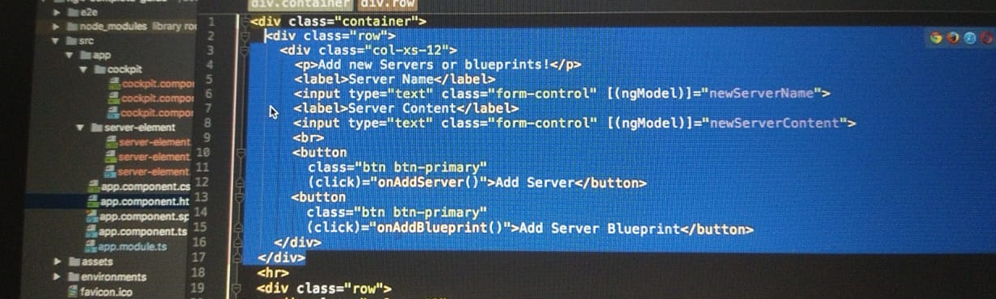

* Code copied will be added to cockpit :
* the methods we're calling here
* So on app server and on app blueprint
* So in the TypeScript code here, I will copy both with cut, both elements here and move them over to our cockpit and will soon also come to NG on in it
* And what this does, as a side note
* Now of course my issue is that I try to push this to erase or to an array which doesn't exist here, server elements
* That array is still in the app component
* We could of course move that
* Oh, and maybe I should also move that closing, call it brace We could of course move this server elements array but then we would no longer have it in our app component and we will need it there too though, because there we still will need to replicate these server elements to create the well service we output here
* So well as a first step, what I can move of course, cut and paste, are the two properties which are used here with two-way binding
* So I can move that to the cockpit but we will have to see what we do about this server elements array
* For now, let's go back to the app component HTML file and take a single server here
* So this panel they have here
* So with that all we have here now is the row and the column
* And the other part will go into the HTML file of the server element because that is a single server
* Now here of course, we have this loop and that's not what I want to have in here, so I'll get rid of it there because I still want to manage my array of server elements in the app component, because we somehow need to be able to manipulate it from the cockpit and then replicate it in the app component to create multiple instances of this server element component which is only a single server
* Keep this in mind
* This is not the list of servers
* Now of course you could set this up differently but this approach I will go with and this approach won't work right now
* We also try to access a element property now inside of our server element component, which we also don't have
* So a couple of things to fix
* I like the general way we split up our app and that we now can add our app cockpit here where we before had the full HTML code, we moved over there and that we can add our app server element component here
* And that we could also replicate this with NG four, let server element of server elements so we can of course also place NG four on a component as you already learned before
* So I like that, but I don't like that the app is broken
* And if we have a look at it that well, we simply get an error that a couple of properties are unknown
* So we somehow, and that is a key part need to get the new server, we add in the cockpit to this array of servers and our app component
* So we kind of need to inform our app component that one of its child components, the app cockpit, changed or that something changed there to which we should react; a new server was added
* And then we also need to get the data we got from the cockpit
* So this new server, which is managed in this array of servers in the app component we need to get the individual server of a single loop iteration here, down to the app server element
* So we need to pass data between components and that of course is a super important task we haven't touched yet but we will dive deeper into right now